

 | Data Collection and Preprocessing Phase
Date |  | 15 JUNE 2025
Team ID |  | SWTID1749902640
Project Title |  | CRIME VISION : Advanced Crime
 |  | Classifaction Learning
Maximum Marks |  | 6 Marks

Preprocessing Template

The images will be preprocessed by resizing, normalizing, augmenting, denoising, adjusting contrast, detecting edges, converting color space, cropping, batch normalizing, and whitening data. These steps will enhance data quality, promote model generalization, and improve convergence during neural network training, ensuring robust and efficient performance across various computer vision tasks.

Section | Description
 | Load and explore image data from Train and Test directories,
Data Overview | count class-wise images, and visualize dataset distribution
 | using bar and pie charts.
Resizing | Resize all input images to a fixed target size of 64x64 pixels for
Resizing | uniformity and compatibility with the neural network input.
 | Normalize image pixel values to the range [0, 1] using the
Normalization | Rescaling layer, which improves model training performance
 | and convergence.
 | (Implicit step in TensorFlow pipeline; can be added manually)
Data Augmentation | Enhance dataset variability by applying techniques like
 | flipping, rotating, etc.
 | Use DenseNet121, a pre-trained model on ImageNet, as the
Transfer Learning | base model to extract features, reducing training time and
 | improving accuracy.
Model Architecture | Build a custom Sequential model by stacking Rescaling,
Model Architecture | GlobalAveragePooling2D, Dense, and Dropout layers,
 | followed by the final output layer.

 | Compile the model using Adam optimizer and
Compilation | categorical_crossentropy loss function with accuracy as the
 | evaluation metric.
Training | Fit the model on training data and validate using 20% of the
Training | training split for 5 epochs, and track the accuracy and loss.
Saving the Model | Save the trained model to disk (crime.h5) for later use in real-
Saving the Model | time prediction or deployment.
Model Evaluation | Load test dataset and evaluate the trained model by comparing
Model Evaluation | predicted class indices with actual labels.
 | Load individual test images, preprocess them (resize, convert to
Single Image Prediction | array, expand dims), predict using the model, and output the
 | predicted crime label.
Web App Interface | Use Flask to build a web application with two routes: one to
Web App Interface | upload an image and one to display the predicted result.
Ngrok Deployment | Use pyngrok to expose the Flask server to the internet via a
Ngrok Deployment | public URL for remote testing and demonstration.
Data Preprocessing Code Screenshots
Resizing
Normalization
Data Augmentation
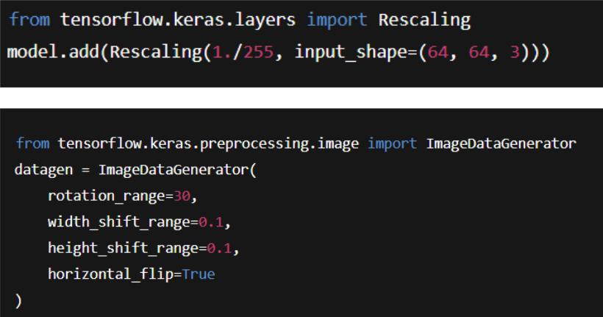
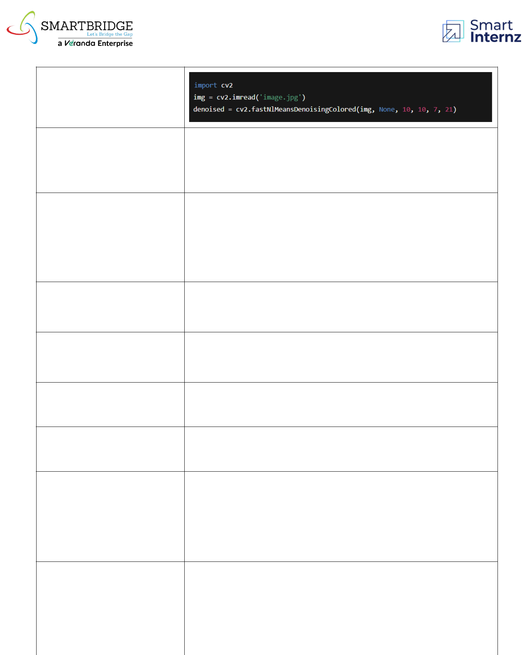

Denoising
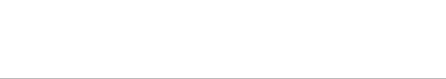
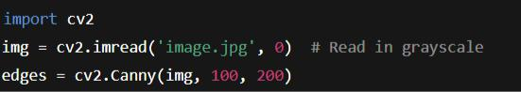

Edge Detection

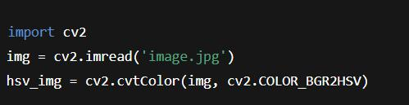

Color Space Conversion

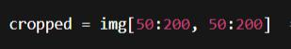

Image Cropping

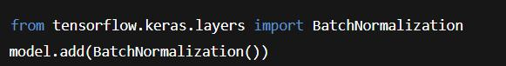

Batch Normalization

Compilation

Training

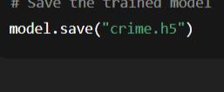

Saving the Model

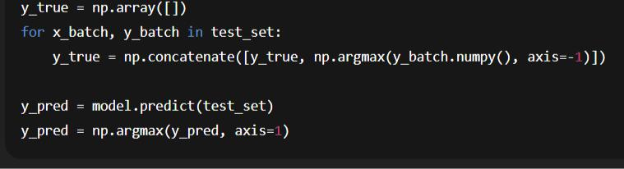

Model Evaluation

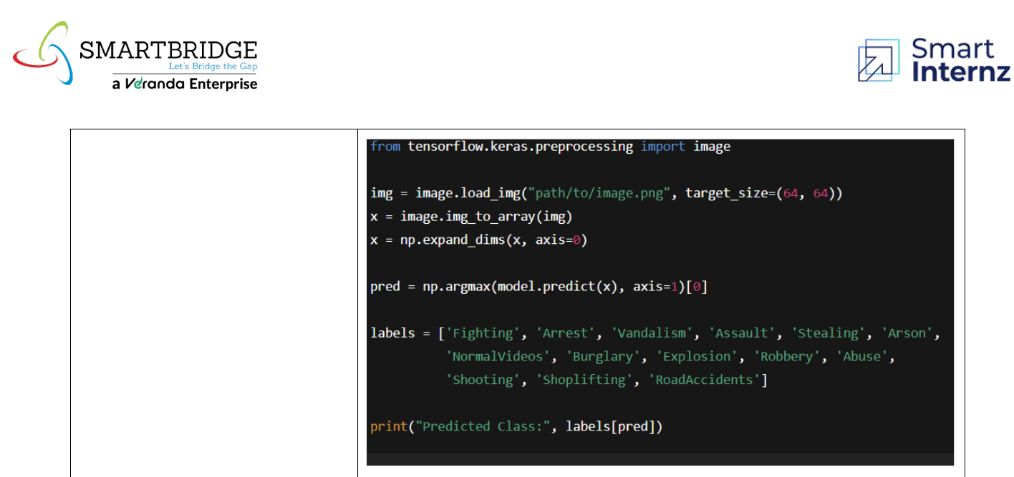

Single Image Prediction

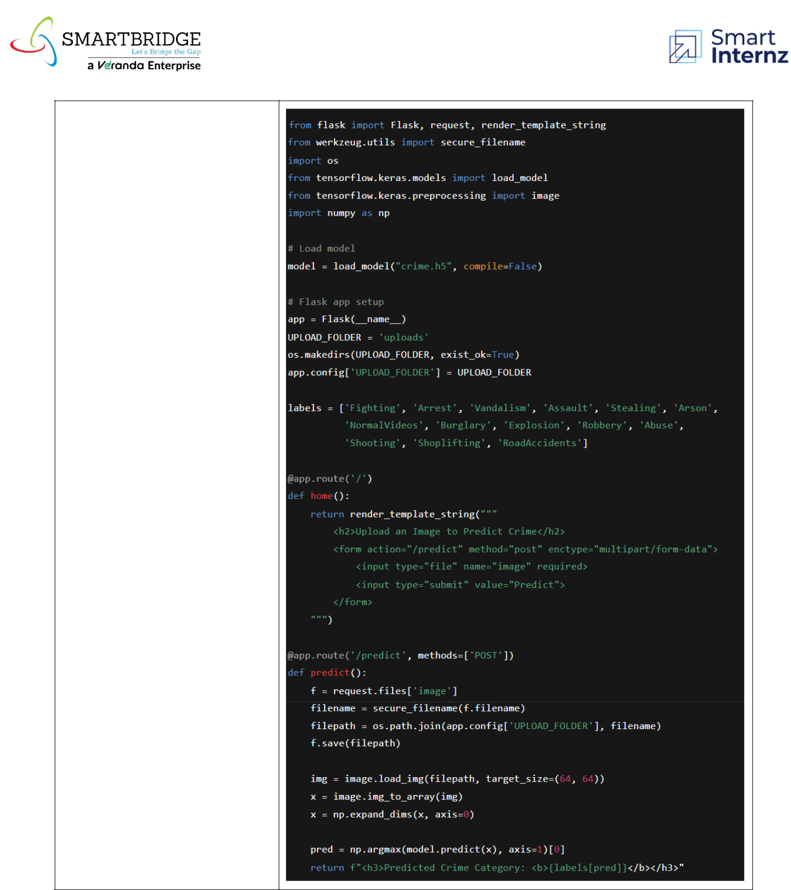

Web App Interface
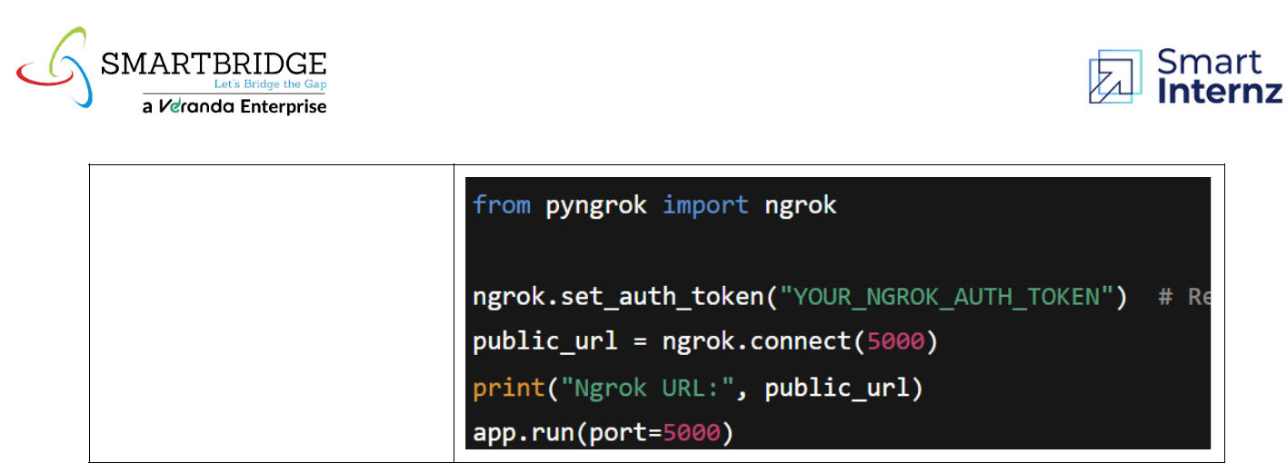

Ngrok Deployment

